Name: Sapargali Temirlan
Group: SE-2403
Instructor: Kozhakhmet Zhaksylyk
PART 3
TASK 5
Deriverables
All deliverables such as the contract files and e.t.c, are inside same directory as this document.
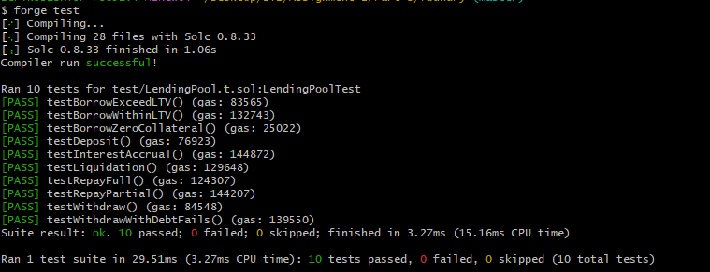
Core Design Decisions
LTV = 75%
Health Factor = (collateral * 75%) / debt
Interest Model: Linear per second
Liquidation threshold: HF < 1
Precision: 1e18
